**Submitted by- Sanket Bollamwar**

**Assignments on String**

Q1. Using features of Java 11, read the data from a text file (**File name:** StudentList.txt). Calculate the count of students and print the names as well as the total count of students on the screen. (If any line in file doesn’t contain a name, for such a record blank space should not be printed in the output)

Hint: Use java 11 features of files and String methods to reduce the lines of code to be written.

**Code:**

package String_Assignments;

import java.io.*;

import java.util.Scanner;

public class Assignment3Q1 {

    public static void main(String[] args) throws IOException {

        File file = new File("C:\\Users\\Hp\\Desktop\\Assignments\\Core Java 11\\Java11Assignments_StudentList.txt");

        Scanner sc = new Scanner(file);

        int count = 0;

        while (sc.hasNextLine()){

            String string = sc.nextLine();

            if(string.length()!=0){

                System.out.println(string.trim());

                count++;

            }

        }

        System.out.println("Total number of students present in the txt file are: "+count);

        sc.close();

    }

}

**Output:**

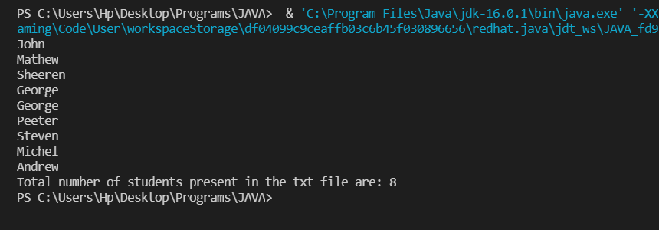

**File**:

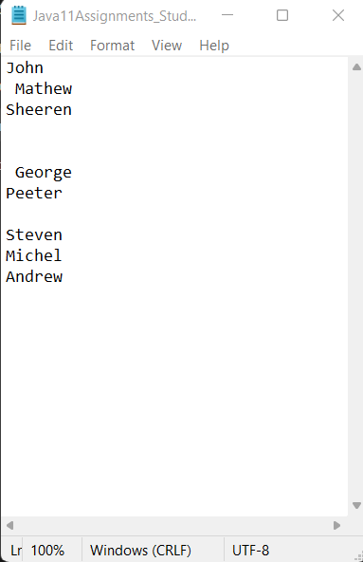

Q2. Write a program with menu to accept the price of certain items and display their total. When user selects Option 1: should accept the prices of different products and insert these prices into first file (each amount to be inserted in a newline in the file). Next, total of these values should be saved in a new file. Option 2: should allow the user to view the total of these prices from the second file.

**Sample Output**:

Select your option (**1**: Insert New Price, **2**: View Purchase Total, **3**: Exit)

> 1

Insert 1st price:

> 100

Price has been saved to the file

Do you want to enter price for more items? (Yes/No)

Yes

Insert 2nd price:

200

Price has been saved to the file

Do you want to enter price for more items? (Yes/No)

No

Select your option (**1**: Insert New Price, **2**: View Purchase Total, **3**: Exit)

2

Total Price of all items is: 300

Select your option (**1**: Insert New Price, **2**: View Purchase Total, **3**: Exit)

3

exit program….

Hint: Use java 11 features of files and String methods to reduce the line of code.

**Code:**

package String_Assignments;

import java.util.Locale;

import java.util.Scanner;

public class Assignment3Q2 {

    public static String ordinal(int i) {

        String[] suffixes = new String[]{"th", "st", "nd", "rd", "th", "th", "th", "th", "th", "th"};

        switch (i % 100) {

            case 11:

            case 12:

            case 13:

                return i + "th";

            default:

                return i + suffixes[i % 10];

        }

    }

    public static void main(String[] args) {

        Scanner sc = new Scanner(System.in);

        int count = 0;

        int price,total = 0;

        int choice;

        do{

            System.out.println("\t\t******************************\t\t");

            System.out.println("\t\t**  1) INSERT NEW PRICE     **\t\t");

            System.out.println("\t\t**  2) VIEW PURCHASE TOTAL  **\t\t");

            System.out.println("\t\t**  3) EXIT                 **\t\t");

            System.out.println("\t\t******************************\t\t");

            System.out.print("\t\tENTER YOUR CHOICE: ");

            choice = sc.nextInt();

            switch (choice){

                case 1:

                    String s = "Yes";

                    do{

                        System.out.print("\t\tInsert "+ordinal(count+1)+" price: ");

                        price = sc.nextInt();

                        total += price;

                        System.out.println("\t\tPrice has been saved to the file");

                        System.out.print("\t\tDo you want to enter price for more items? (Yes/No): ");

                        s = sc.next();

                        count++;

                        System.out.println();

                    }while(s.equalsIgnoreCase("Yes"));

                    break;

                case 2:

                    System.out.println("\t\tTotal Price of all items is: "+total);

                    break;

                case 3: System.exit(0);

                default : System.out.println("\t\tPLEASE ENTER THE CORRECT CHOICE!");

            }

        }while(choice!=3);

    }

}

**Output:**

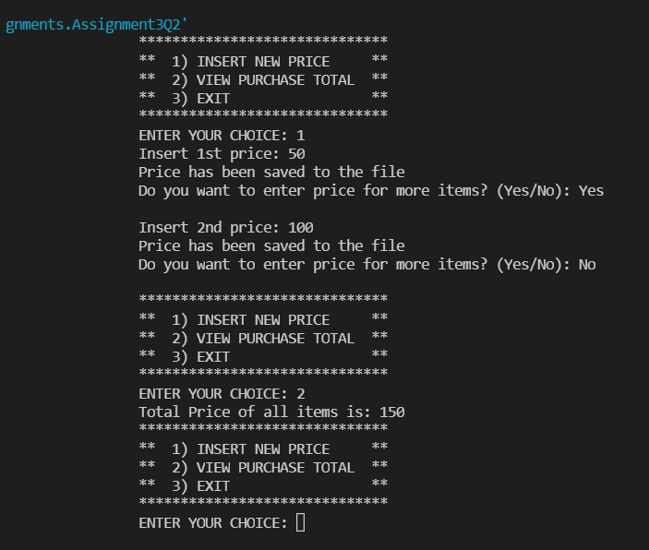

Q3. Write a code using HttpClient API which sends a GET request

to https://httpbin.org/get, and print out the response header, status code, and body for the given URL

.

**Sample output** could be (Note: date and other attribute values may differ in your results):

access-control-allow-credentials:[true] access-control-allow-origin:[*] connection:[keep-alive]

content-length:[273]

content-type:[application/json] date:[Fri, 06 Aug 2021 13:07:41 GMT]

server:[gunicorn/19.9.0] 200

{

"args": {}, "headers": {

"Content-Length": "0",

"Host": "httpbin.org",

"User-Agent": "Java 11 HttpClient Bot",

"X-Amzn-Trace-Id": "Root=1-610d341d-092dc33f698b192a219426d1"

},

"origin": "43.255.221.184",

"url": "https://httpbin.org/get"

}

**Code:**

import java.io.*;

import java.net.*;

import java.util.ArrayList;

import java.util.Date;

import java.util.HashMap;

import java.util.List;

import java.util.Map;

public class Assignment3Q3 {

    public static void main(String[] args)

    {

        try

        {

            URL url = new URL("https://httpbin.org/get");

            //open the connection to the above URL.

            HttpURLConnection http = (HttpURLConnection)url.openConnection();

            URLConnection urlcon = url.openConnection();

            Map<String, List<String>> header = urlcon.getHeaderFields();

            //print all the fields along with their value.

            for (Map.Entry<String, List<String>> mp : header.entrySet())

            {

                System.out.print(mp.getKey() + " : ");

                System.out.println(mp.getValue().toString());

            }

            System.out.println("\nGet Response Header By Key ...");

            List<String> contentLength = header.get("Content-Length");

            if (contentLength == null) {

                System.out.println("'Content-Length' doesn't present in Header!");

            } else {

                for (String header1 : contentLength) {

                    System.out.println("Content-Lenght: " + header1);

                }

            }

            int statusCode = http.getResponseCode();

            System.out.println("Status Code: "+statusCode);

            System.out.println();

            System.out.println("Complete source code of the URL is-");

            System.out.println("---------------------------------");

            //get the inputstream of the open connection.

            BufferedReader br = new BufferedReader(new InputStreamReader

                    (urlcon.getInputStream()));

            String i;

            //print the source code line by line.

            while ((i = br.readLine()) != null)

            {

                System.out.println(i);

            }

        }

        catch (Exception e)

        {

            System.out.println(e);

        }

    }

}

**Output:**

